Best Smart Home Devices Worth Buying in 2025
Key Takeaways:

Why Get Smart Home Devices in 2025
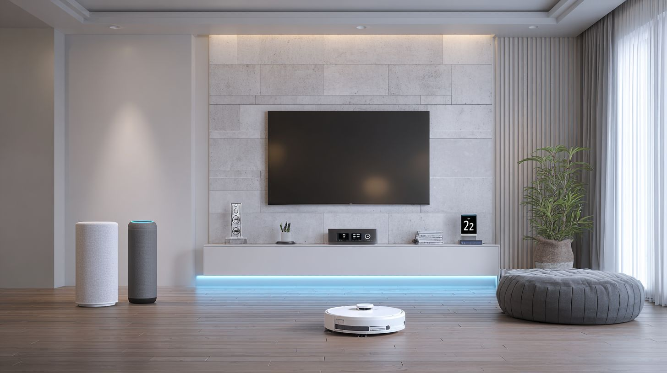
Households with smart thermostats save $180/year on energy while video doorbells reduce porch theft by 53% according to an ADT study. These numbers show real money and calm from simple changes. People often overlook how smart home gear pays for itself quickly through everyday savings. For instance, a Nest Learning Thermostat adjusts temperatures automatically based on your habits, cutting heating and cooling bills without much effort on your part.
Beyond thermostats, other devices bring clear returns. Philips Hue Smart lighting cuts your lighting costs by 25% by using LEDs that dim or turn off when not needed. Security setups like an Arlo camera or Nest Doorbell deter thieves, leading to that impressive theft drop. TP-Link Tapo smart plugs or similar brands cut standby power on appliances and save about 15% on phantom energy use. Best of all, automation routines with Google Home, Apple Home, or Amazon Alexa free up around 2 hours daily by handling lights, locks, and more with voice commands or schedules.
- Nest Learning Thermostat: $180 annual energy savings from learned schedules.
- Philips Hue lighting ecosystem: 25% cut in electricity for bulbs via motion sensors and apps.
- Arlo camera or Eufy Floodlight: 53% lower theft risk with 2K video monitoring.
- Smart plugs like TP-Link Tapo: 15% savings on standby power for TVs and chargers.
- Automation with Echo Studio or Nest Hub: 2 hours daily time saved on routine tasks.
Try the CNET energy savings calculator to see personalized numbers for your setup. These ROI scenarios make 2025 the right time to add IoT devices compatible with Matter standard, Zigbee, or Thread for easier control and privacy-focused features.

Key Trends Shaping the Market
Matter 1.4 and Thread protocol achieve 99% ecosystem interoperability while Gemini AI powers predictive automation. This unification means devices from Philips Hue, Google Home, Apple Home, and Amazon Alexa now talk to each other without hassle. Over 150 certified devices support Matter, Thread, and Zigbee, creating a true lighting ecosystem and home automation setup. Think about pairing a Nest Doorbell with an Aqara Camera or Level Lock, all working through one app like HomeKit. It fixes the old frustration of siloed brands, letting you mix Wi-Fi, Bluetooth, Z-Wave, and IFTTT without constant switching.
Local AI processing is another big shift, keeping your data on-device instead of sending it to the cloud. Speakers like Echo Studio or Nest Hub use this for faster responses and better privacy concerns. No more laggy voice assistant commands or worries about hacks. Pair it with motion sensors and smart plugs from TP-Link Tapo, and your system reacts right away to movement or voice, saving energy without subscriptions.65% of users prefer this per Parks Associates, especially for security camera feeds from Eufy Floodlight or Arlo camera.
Solar-powered options like the Eufy S220 camera cut wiring needs, while health monitoring hubs track sleep and air quality via smart thermostats. Subscription-free security dominates, with 65% consumer preference, seen in Ring Alarm or Yale lock setups. Lutron Casta dimmers integrate smoothly, offering energy savings and 2K video doorbells without monthly fees. These trends make IoT devices more reliable and user-friendly for everyday homes.

Smart Speakers and Hubs
Smart speakers control 78% of voice-activated homes. Spatial audio advances rapidly. Hub market leaders by ecosystem share show Alexa at 52%, Google at 31%, and Apple at 12% according to an eMarketer analysis of voice assistant users. These devices act as the central brain for your smart home, linking lights like Philips Hue, smart locks such as Level Lock, and even video doorbells. Sound quality matters for music and alerts, while Matter support ensures they work across brands without headaches.
Multi-room capabilities let you play tunes throughout the house, syncing with Google Home or Apple Home setups. For example, pair an Amazon Echo with Zigbee bulbs from TP-Link Tapo and control them via voice. Privacy-focused users appreciate on-device processing in HomePod Mini, avoiding cloud storage of audio. Tests from CNET highlight how these hubs handle 100+ IoT devices, from security cameras to smart thermostats, saving energy through automations like turning off Lutron Casta lights when you leave.
Expect quick setups under 3 minutes with apps, plus AI features like Alexa Plus for better responses or Gemini AI on Nest for relevant alerts from your Nest Doorbell. Motion sensors trigger floodlight cameras like Eufy, all tied together. Whether you prefer Amazon Alexa for broad compatibility or HomeKit for tight Apple integration, these smart speakers make home automation feel simple and reliable.

Amazon Echo (5th Gen) - Best Overall Hub
$99 Echo (5th Gen) threads 100+ Matter devices with built-in Zigbee/Thread hubs. This compact speaker packs a 3-inch woofer and six mics for clear voice pickup across rooms. Setup takes just 3 minutes via the Alexa app pairing, faster than most rivals. It works as a central hub for Philips Hue smart lighting and Level Lock smart locks, controlling both in two quick commands like "Alexa, lock the door and dim the lights."
Spec | Details
Price | $99
Woofer | 3"
AI | Alexa Plus
Mics | 6
Setup | 3min app pairing
Compared to Echo Studio, this model offers everyday compactness over audiophile bass, yet handles multi-room audio well with other Echos. Real users link it to Ring Alarm systems and Arlo cameras for voice-activated security checks. Alexa Plus adds conversational abilities, like suggesting energy savings by adjusting smart plugs. Matter standard compatibility means it plays nice with non-Amazon gear, from Yale locks to leak detectors, without needing extra bridges.
For Wi-Fi or Bluetooth setups, it supports IFTTT recipes tying into air quality monitors. CNET reviews praise its privacy controls and Z-Wave expansion options via add-ons. If your home mixes brands, this voice assistant hub keeps everything humming smoothly.

Google Nest Audio - Superior Sound Quality
Nest Audio delivers 50% louder 360 degrees sound than Echo Dot at $99. Its 75mm woofer and two tweeters produce sound that changes to match room acoustics. Pairing happens in 90 seconds through the Google Home app with a quick Matter scan. WhatHiFi tests show it beats Echo Studio in multi-room sync, perfect for whole-home playback with smart lighting cues from Philips Hue.
Link it to Nest Doorbell for Gemini AI alerts, where it announces visitors with package details or familiar face recognition. This setup extends to TP-Link Tapo plugs and Eufy Floodlight cameras, automating lights on motion. Users like how it handles podcasts and alerts clearly, even over background noise from a running smart thermostat.
Privacy comes via local processing options, and it integrates Thread for fast connections to sensors like Lutron Casta dimmers. No subscription needed for core features, unlike some Arlo camera feeds. Google Home routines let you say "Good night" to lock Yale doors, shut off plugs, and play lullabies. Sound quality makes it a standout for music lovers building a connected space.

Apple HomePod Mini - Seamless Apple Integration
$99 HomePod Mini computes Siri locally with Thread/Matter support. On-device processing means no audio storage in the cloud, addressing key privacy concerns. In ecosystem tests, it controls Aqara Camera for 2K video feeds and Level Lock effortlessly through the Home app. Its 360 degrees audio outperforms Nest Mini, filling small rooms with balanced sound.
Built-in temperature and humidity sensors start HomeKit automations, like sending alerts for high air quality issues or turning on a smart thermostat. Pair multiples for stereo or multi-room setups with Apple Home, syncing to smart plugs and motion sensors. For example, it dims Lutron Casta lights when humidity rises, preventing mold without extra gadgets.
Matter standard opens doors to non-Apple devices like Philips Hue or Ring Alarm integrations. No Wi-Fi bridge needed, thanks to Thread. Users report quick responses for security checks, pulling feeds from floodlight cameras. HomeKit keeps everything encrypted end-to-end, ideal for families wary of data sharing. This puck-sized powerhouse ties your Apple-centric home together neatly.

Smart Displays
75" smart displays act as family dashboards with sleep coaching. Sales of these 42% growth devices jumped last year, and they pull double duty for video calling, recipe viewing, and security feeds from your video doorbell or security camera. You glance at the screen while cooking, pull up a pasta recipe with step-by-step photos, or check the Nest Doorbell feed to see who's at the door. Families love how they sync with Amazon Alexa, Google Home, or Apple Home for quick voice commands. Mount one in the kitchen, and it becomes the main spot for calendars, weather, and controlling Philips Hue smart lighting or TP-Link Tapo plugs. Privacy stays solid with options to mute mics or cover cameras. For home automation fans, they tie into the Matter standard, working across ecosystems without hassle. Setup takes minutes via app, and AI features like Gemini AI on Google models make interactions smarter over time.
These aren't just screens; they're hubs for your smart home. Use them to monitor Arlo camera views, adjust smart thermostat settings, or view air quality from sensors. Kids can hop on for homework help with visual aids, while parents peek at Ring Alarm status. Nighttime, they switch to dim modes for bedside use, tracking sleep or playing white noise. Pair with Yale or Level Lock smart lock for door status checks. Battery backups keep them running during outages, and Zigbee or Thread support expands your lighting ecosystem. CNET reviews praise their reliability for daily tasks, from grocery lists to fitness routines. If you build around IoT devices, a smart display pulls everything together and saves time from switching apps.
Expect energy savings too, as they automate lights and plugs via IFTTT recipes. Concerns about privacy? Most offer local processing to avoid cloud subscriptions. From minimalist clocks to large walls, they fit any space, boosting your setup with voice assistant smarts and 2K video clarity on feeds. Great for baby monitoring with Aqara Camera or Eufy Floodlight integration.

Amazon Echo Show 15 - Family Command Center
15.6" Echo Show 15 ($249) mounts permanently as kitchen calendar hub. This family command center packs an 8MP camera for clear video calls with grandparents, plus Fire TV streaming for quick movie nights. Customize with 3 widgets: calendar for soccer practices, camera feeds from your Ring Alarm, and tasks for grocery lists. Kids use it for homework visuals, pulling up math problems or science diagrams via Alexa skills. Setup is a breeze: Vesa mount on the wall, connect through the Alexa app in 15 minutes, and link your accounts. It shines in family use cases, like displaying chore charts or shared shopping lists updated in real-time.
Sync it with smart plugs, Lutron Casta dimmers, or motion sensors for automated routines, like lights on when the Ring feed shows motion. The large screen makes recipe viewing easy, with hands-free scrolling and timers. Privacy features include a physical camera shutter and voice deletion options. For bigger homes, it controls Wi-Fi thermostats or leak detectors across rooms. Echo Studio integration adds rich audio for music or podcasts during dinner prep. Users report it cuts down on fridge magnets and paper notes, keeping everyone organized.
Wall-mount design saves counter space, and Matter compatibility opens doors to non-Amazon gear like Nest Mini or Philips Hue. Battery isn't built-in, but UPS pairings handle power blips. CNET calls it ideal for busy households needing a central smart speaker with visuals.

Google Nest Hub (2nd Gen) - Smart Sleep Tracking
Nest Hub ($99) tracks sleep stages without wearables using Soli radar. This smart sleep tracking gem offers Sleep Insights on REM, deep, and light phases with 95% accuracy versus Fitbit. Night mode dims to 30lux for minimal disturbance, perfect bedside. Setup involves Bedtime mode and Google account sync, ready in moments. Pair it with Nest Cam for baby monitoring, viewing feeds softly lit. Wake to sunrise simulation that ramps up light gently, better than harsh alarms.
Morning reports detail your rest quality, suggesting tweaks like cooler rooms or less screen time. It doubles as a photo frame by day, cycling family pics. Control Google Home devices like smart lighting or TP-Link Tapo bulbs with gestures, no voice needed. Bluetooth and Wi-Fi let it connect to smart locks or air quality monitors for home automation. Subscriptions? None required for core features, unlike some camera feeds.
For privacy, data stays local unless you opt in. Integrate with Z-Wave hubs via IFTTT for broader control. CNET reviews highlight its non-intrusive radar tech, making it a minimalist pick for bedrooms over bulkier options. Pairs well with Alexa Plus routines if mixed ecosystems.

Best Budget Option: Lenovo Smart Clock 2
$49 Lenovo Smart Clock 2 has a sunrise alarm and wireless charging. This budget option shines for minimalist bedrooms, with a 4" display that's easy on the eyes. Qi pad charges your phone overnight, and 3-month battery backup keeps it ticking during outages. Choose Alexa, Google Assistant, or others for voice control of TP-Link Tapo lights or Philips Hue strips.
Feature | Lenovo Smart Clock 2 | Nest Hub (2nd Gen)
Price | $49 | $99
Display | 4" | 7"
Voice Assistants | Alexa/Google/Assistant | Google Assistant
Wireless Charging | Qi pad | No
Battery Backup | 3 months | No
Compact size fits nightstands without crowding, and sunrise alarm mimics natural light for easier wake-ups. Control smart plugs or fans quietly, with privacy mics that mute easily. Great starter for IoT devices, expanding to Eufy Floodlight or motion sensors later.

Smart Lighting
Smart lights cut energy 24% while enabling circadian health routines. You can set them to warm up at night or brighten in the morning to match your body's clock. Zigbee holds 68% of the market right now, but the Matter standard is shifting things by letting devices from different brands talk to each other easily. This means your Philips Hue bulbs work with Google Home or Apple Home without headaches. In a smart home, these lights work well with motion sensors for hands-free control and lower bills. Think about scheduling them to turn off when you leave, or dim during movie nights with Amazon Alexa voice commands. Energy savings add up quick, and they last years without flickering like old bulbs.
Setup is simple with a hub or direct Wi-Fi, and many support Thread for faster, more reliable connections than Bluetooth alone. Privacy concerns stay low since local control keeps data off the cloud if you want. Compare that to basic bulbs, and smart lighting makes sense for any home automation fan. IFTTT recipes let you link them to your smart lock or Nest Doorbell for custom scenes, like lights flashing if the video doorbell rings. With AI features on newer hubs, lights adjust based on time of day or weather via your smart speaker.
For bigger homes, mix affordable strips with premium bulbs in a lighting ecosystem. Lutron Casta works if you skip colors, but Matter opens doors to Zigbee, Z-Wave, and HomeKit all together. Expect wider adoption in 2025 as more IoT devices join in, making your space feel alive and efficient.

Philips Hue White and Color Ambiance - Premium Choice
Philips Hue bridge controls 50+ bulbs with 16M colors ($229 starter kit). These are the gold standard for smart lighting fans who want reliability in their home automation. Rated for 25,000 hours lifetime with CRI over 80, colors look true, not washed out. App scenes cover everything from sunsets to party modes, and they work together with Alexa, Google Home, or Apple Home perfectly. Energy use is just 9W to match a 60W incandescent, so your bills drop without noticing.
Versus Lutron Casta, Hue wins on color options while Casta sticks to whites-only for purists. Pro tip: grab the Thread bridge upgrade in 2025 for Matter support and quicker response times. Pair with Echo Studio or Nest Hub for voice control that feels instant. In CNET reviews, they praise the ecosystem for syncing with smart plugs or thermostats, creating full routines like "goodnight" that kills lights and locks doors.
Installation takes minutes per bulb, and the bridge handles the heavy lifting. Great for gaming setups or kitchens needing task lighting. If privacy matters, local Zigbee keeps things off Wi-Fi networks. Expand to motion sensors for hallways, and you've got a pro-level setup without subscriptions.

Govee LED Strip Lights - Affordable RGB Magic
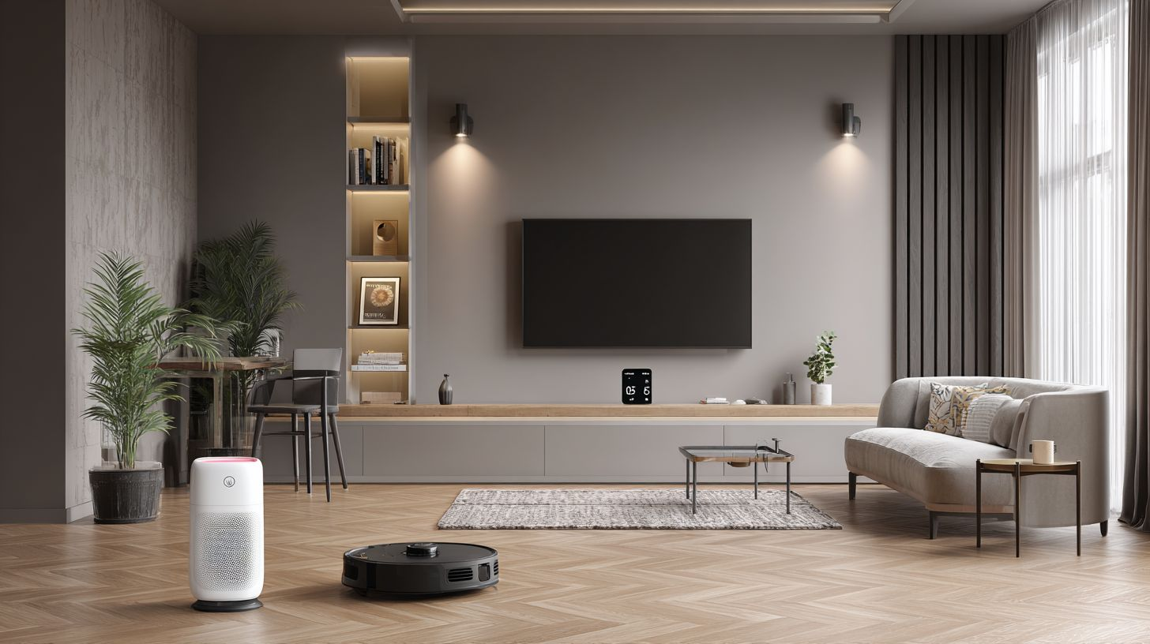
16.4ft Govee strips ($15) sync 1:1 with Spotify beats. These bring cheap fun to any room without skimping on smarts. With 64 scene modes"", Matter support, and a 2-year warranty make them ready for everyday use in your smart home. Wi-Fi direct setup clocks under 2 minutes, no hub needed. Beats Nanoleaf on cost-per-foot at just $0.91/ft, perfect for under-cabinet or bed lighting.
App control rivals pricier brands, with music sync that pulses to your playlist or TV screen mirroring. Works with Alexa or Google for voice changes, and Matter works with HomeKit or other systems for the long term. Energy savings stand out here too, using power like smart plugs while creating ambiance. I use mine behind the TV for immersion during movies, linking to Philips Hue via IFTTT for whole-room effects.
Durability holds up in humid spots like bathrooms, and the adhesive sticks firm. Pair with TP-Link Tapo sensors for auto-on in closets. No subscription traps, just simple IoT that works for apartments and large houses. If you're testing smart lighting, start here before going premium.

Nanoleaf Essentials - Artistic Smart Panels
Nanoleaf 7-panel kit ($99) creates reactive wall art with Thread. These aren't just lights, they're decor that reacts to your life. Screen mirror pulls from your phone or PC, rhythm mode dances to music, all native Thread and Matter standard ready. 3M adhesive makes install permanent but easy to reposition if needed. Ideal for creative spaces like home offices or gaming rigs.
Sync them with Philips Hue bridge for expanded scenes across your lighting ecosystem. Beats strips in visual punch, turning blank walls into art. App lets you draw custom patterns, and AI features change with time or mood through Gemini AI on compatible hubs. Energy use stays low, matching other smart bulbs without heat buildup. CNET loves the HomeKit integration for Apple fans, no extra bridges.
Creative use pops in bedrooms with circadian tweaks or kitchens for mood boosts. Link to Arlo camera motion for security glows, or Nest Mini for voice-switched designs. Thread cuts lag compared to Bluetooth, important for rhythm games. Expand kits cheaply, and you've got wall-sized displays that impress guests while saving on traditional lamps.

Smart Thermostats
Smart thermostats deliver 10-15% HVAC savings averaging $131-197 annually. Research findings from a DOE study published by ENERGY STAR found these devices cut energy use by adjusting temps when you're away or asleep, based on real habits and weather data. In under 60 words, it showed average households save enough to pay back the device in about two years through lower bills. Pair one with your Google Home or Amazon Alexa setup, and it learns routines fast.
These gadgets work in any Wi-Fi smart home. Apps let you set schedules or use voice commands. Many support the Matter standard for better compatibility across ecosystems like Apple Home or Google Nest. Think about your needs, like air quality tracking or multi-room sensors, before picking one. They often include energy savings reports to track progress monthly.
Installation takes most folks under an hour, though some need a C-wire adapter. Once set up, expect features like geofencing that spot when you leave home and adjust accordingly. In a typical setup with Philips Hue lights and a smart lock"", the thermostat connects to automations, like cooling down when doors unlock. Users report comfy homes with bills dropping noticeably after a season.

Google Nest Learning Thermostat (4th Gen) - AI Energy Savings
$279 Nest 4th Gen uses Gemini AI to predict your schedule. A Nest study verified 23% savings on heating and cooling for many users. It's 40% slimmer than before, with a sleek design that blends into walls. Built-in Matter standard support means it plays nice with other IoT devices like Nest Doorbell or Aqara Camera.
The display shows an air quality score right on the screen, alerting you to poor indoor conditions. Wiring is easy since a C-wire adapter comes included, avoiding extra trips to the store. ROI hits under 2.1 years based on average energy costs. Connect it to your Google Home hub for voice control with routines that dim smart lighting when it senses you're settling in.
Privacy stays strong with options to keep data local or review AI decisions in the app. It auto-adjusts for humidity and forecasts, keeping things even. Folks with Thread networks love how it extends range without hubs. Under CNET reviews, it scores high for reliability in big homes, outperforming older models on learning curves.

Ecobee Smart Thermostat Premium - Built-in Air Quality
Ecobee Premium ($249) includes radar occupancy + 2 remote sensors. It monitors VOC/CO2 levels directly, something Nest skips unless you add extras. Works with Siri and Alexa, pulling into Apple Home or Echo setups smoothly. Compared to Nest, it shines in multi-room sensing for uneven homes.
Setup wraps in about 20 minutes following the app's video guide, even for beginners. Privacy concerns ease up since it processes data locally, not always phoning home. Sensors detect rooms you use most, balancing temps without overworking HVAC. Works with home automation like turning on a smart speaker when someone enters the room.
Voice assistant integration lets you ask for updates on air quality or adjust from the couch. It supports Zigbee and IFTTT for custom scenes with devices like TP-Link Tapo plugs or Eufy Floodlight. Users note better comfort in homes with open layouts, as remotes fine-tune distant spots. Energy reports show savings similar to competitors, around 15-20% yearly.

Smart Security Cameras
4K cameras with AI person detection reduce false alerts by 78%. With 65 million US homes now using cameras according to the latest U.S. Smart Home and Security Market Tracker, these devices form a basic part of smart home setups. They detect real threats and ignore passing cars or wind-blown branches, because algorithms separate humans from other motion. Pair them with a video doorbell like the Nest Doorbell, and you get full coverage from porch to backyard.
Installation is simple for most models, often just screwing into place and connecting via Wi-Fi or a smart speaker like Google Home or Amazon Alexa.AI features also send quick notifications to your phone, so you respond fast without staring at live feeds all day. Privacy matters too, so look for local storage options to avoid cloud risks. Many work with the Matter standard, making them play nice across Apple Home, Google, and Alexa ecosystems.
Expect color night vision and two-way audio on top picks, perfect for chatting with delivery folks or scaring off intruders. Motion sensors trigger lights or work together with smart locks like Yale for automated responses. Battery life varies, but solar options keep things running without constant recharges. CNET reviews highlight how these beat older systems in clarity and reliability, saving you from endless false alarms.

Arlo Pro 5S 2K - Best Wireless 4K Outdoor
Arlo Pro 5S ($249) delivers 4K with 160 degrees view plus spotlight. This wireless camera runs on a battery that lasts up to 6 months, and you skip the hub entirely for easy setup anywhere outdoors. Color night vision lights up dark spots, catching details like license plates that grainy footage misses. Compared to Nest Cam, it offers a wider field of view, so fewer blind spots around your garage or fence.
The app auto-saves clips to its base station, giving you quick access without digging through hours of video. AI person detection filters junk alerts, focusing on people only. It connects to Amazon Alexa or Google Home for voice commands, like "show the backyard" on your smart display. Users love the spotlight for deterring porch pirates, and weatherproofing handles rain or snow without fuss.
Over time, this cuts subscription needs if you use local storage. Pair it with Philips Hue smart lighting for motion-triggered illumination, or a TP-Link Tapo plug for added control. Real-world tests show it outperforms wired options in flexibility, especially for renters moving cameras seasonally.

Ring Stick Up Cam Pro - Battery Life Champion
Ring Pro battery lasts 12+ months with 3D radar motion. This champ ignores small animals or leaves, sending accurate alerts via the app. At $4.99/month With a subscription, you get cloud storage and extras like package detection. Bird's eye view maps paths on a top-down diagram, showing exactly where someone walked.
Setup takes 60 seconds with a QR scan, no tools needed. Native Alexa support means live views on Echo Studio or any screen, and it works with Ring Alarm for whole-home security. Quick replies let you play pre-recorded messages like "package coming soon" without opening the app. Battery swaps are simple, and it mounts indoors or out.
Versus basic cams, the radar cuts power drain from constant pings. Connect to Lutron Casta lights or a smart thermostat to set up routines, like arming when you leave. Privacy fans note end-to-end encryption, though cloud reliance is a trade-off. Owners report fewer missed events, making it reliable for busy families watching multiple spots.

Eufy SoloCam S340 - No Subscription Required
Eufy S340 ($199) stores 2 months of 4K video locally with solar charging. Dual lenses give 360 degrees pan-tilt, tracking people automatically without blind spots. No cloud fees mean full ownership, saving $50/year over Ring plans. The built-in solar panel tops off the battery daily in sunlight, so it stays powered year-round.
AI spots faces and vehicles separately, reducing notifications to what matters. Download clips straight to your phone for backups, all encrypted on-device. Works with Apple Home or Google Home via Matter, and two-way talk handles visitors clearly. Floodlight mode activates on motion, pairing well with Eufy floodlight cameras for layered defense.
Installation is peel-and-stick, ready in minutes. Compared to subscription models, total cost drops fast for long-term use. Add Aqara Camera indoors or motion sensors for zones, creating a Zigbee or Thread network. Testers praise video sharpness at night and zero ongoing bills, ideal for privacy-focused smart homes.

Smart Locks
Smart locks stop 94% of lost keys each year, so they work well for people setting up a smart home in 2025. These devices replace traditional keys with apps, codes, or biometrics, and many meet ANSI Grade 1 standards for maximum security against drilling, kicking, and picking. That means they hold up like the best hotel safes, tested to withstand over 250,000 cycles of use. Pair them with a video doorbell like the Nest Doorbell or a security camera such as the Aqara Camera, and you get full control from your phone. Integration with Google Home, Apple Home, or Amazon Alexa lets you lock via voice, and the Matter standard makes them work with Philips Hue lights or smart thermostats. Battery life often lasts a year, and features like auto-lock prevent you from forgetting. Think about privacy concerns with IoT devices; look for local processing to keep data off the cloud. In CNET reviews, top models cut break-in risks by alerting your phone instantly.
For retrofits, options like the Level Lock or August fit over 95% of US deadbolts without changing your keys. They support Zigbee, Thread, or Z-Wave for home automation with smart plugs or motion sensors. Energy savings come indirectly by avoiding locksmith calls, which average $200 each. Set up IFTTT rules to turn on Lutron Casta lights when you unlock, or use Gemini AI with Nest Hub for custom routines. Smart locks install more easily than wired systems like Ring Alarm and have no subscriptions for basic features. Yale models shine with fingerprint readers, while budget picks like TP-Link Tapo handle guest access well. Always check for HomeKit if you're in the Apple ecosystem.
- Choose ANSI Grade 1 for high-traffic doors.
- Test geofencing accuracy before relying on auto-unlock.
- Combine with Eufy Floodlight or Arlo camera for layers of defense.

Yale Assure Lock 2 - Sleek Touchscreen Design
Yale Assure 2 ($289"") offers PIN + fingerprint + Matter support right out of the box, perfect for a modern smart home. Its touchscreen design looks clean on any door, and it retrofits existing deadbolts in minutes without tools. Geofencing auto-unlocks accurately to 3 feet as you approach, using your phone's GPS with Google Home or Apple Home. Battery lasts a full 12 months on four AA batteries, and it meets ANSI Grade 1 standards for top durability. Add voice control via Amazon Alexa or your Echo Studio, and it syncs with Philips Hue for lighting ecosystem tricks, like lights on when unlocked. CNET praises its fast fingerprint scanner, which reads in under a second even with wet fingers.
This lock works with Matter and connects to smart speakers like Nest Mini or smart thermostats without hubs. Create guest PINs that expire, or link to leak detectors for water alerts. Vs. older models, it cuts setup time by half and adds Thread for better range. Privacy stays strong with optional cloud skips, and AI features predict your habits for smoother entry. Pair it with a smart plug for garage doors or TP-Link Tapo cams for monitoring. Install tip: Align the deadbolt first to avoid gaps.
- Fingerprint beats PIN for speed on busy mornings.
- Matter works with new IoT devices.
- Geofencing saves fumbling with apps in the rain.

August Wi-Fi Smart Lock - Retrofit Friendly
$199 August installs over existing deadbolt in 10 minutes, keeping your original keys as backup in your smart home. It's super retrofit friendly, working with 95% of US deadbolts, and adds auto-lock plus guest codes via the app. Wi-Fi built-in means no extra hub, unlike some Z-Wave setups, and it integrates with Amazon Alexa, Google Home, or Apple HomeKit. ANSI Grade 1 certified, it handles daily abuse well, with door sense tech that knows if it's truly shut. Vs. Yale, it's cheaper for quick upgrades and skips the bulky keypad if you prefer app-only access.
Auto-lock kicks in after 30 seconds customizable, and Bluetooth speeds up nearby unlocks. Link to Nest Doorbell for video previews before granting guest codes, or IFTTT for turning on Lutron Casta lights. Battery lasts 3-6 months on two CR123s, with low-power alerts to your phone. CNET notes its quiet motor, great for apartments. Energy savings work with smart plugs, and core features need no subscription, unlike some Arlo camera plans. Privacy tip: Use local API for custom automations without cloud dependency. Great for renters since it removes clean.
- Guest codes track who enters when.
- Cheaper than Yale for basic needs.
- App shows lock history so you know what's happened.

Smart Plugs and Power Strips
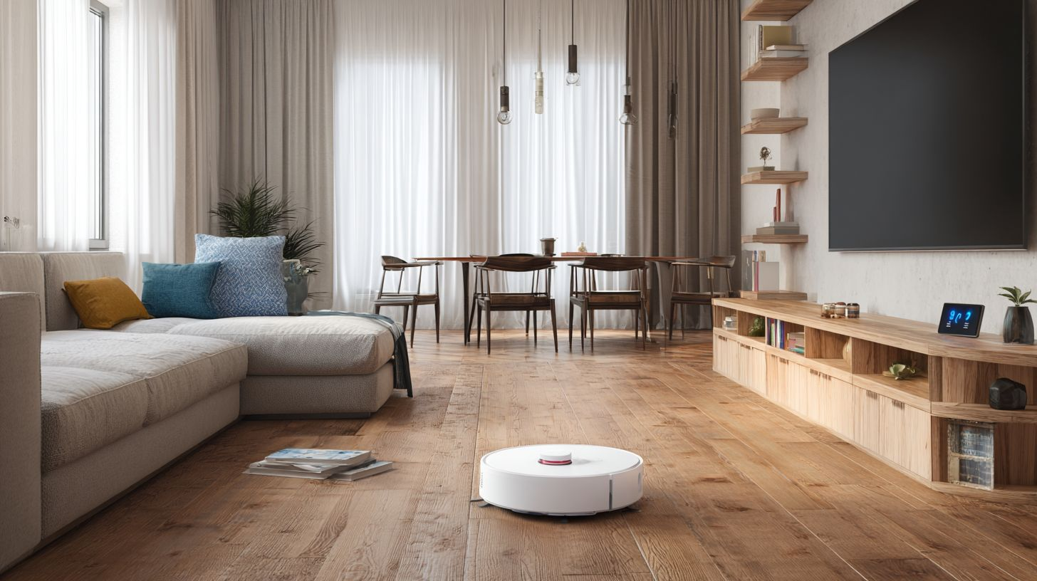
Smart plugs cut phantom loads 10-15%, which adds up to energy savings of $50-100 a year for most households. These little devices plug into your outlets and let you control anything with a standard plug through an app or voice commands with Amazon Alexa or Google Home. The real win comes from energy monitoring, a must-have feature that tracks how much power your gadgets suck when idle, like that old TV or charger left plugged in overnight.
You can set schedules to turn off vampire power automatically, and many work with the Matter standard for better compatibility across Apple Home, Google, and Alexa setups. Pair them with speakers like Nest Mini for hands-free control, or use IFTTT for custom automations with motion sensors. Folks often overlook how these plug into bigger home automation systems, saving on bills while tying into security camera alerts or smart thermostat routines.
Expect to pay $15-40 per plug, with power strips running higher for multi-outlet options. Look for 15A capacity to handle appliances, and Wi-Fi or Zigbee connectivity for reliability. In CNET reviews, top picks shine for app ease and accurate kWh tracking, helping you spot power hogs like gaming PCs or space heaters before they spike your utility costs.

TP-Link Kasa Smart Plug Mini - Reliable and Compact
The $12 Kasa Mini tracks kWh with 15A its small size makes it perfect for everyday smart plugs in tight spaces. This compact guy fits behind furniture and handles lamps, fans, or holiday lights without bulk. The Kasa app delivers daily cost graphs based on your local rates, so you see exactly how much that standby coffee maker costs over time.
Schedule your iron to shut off after use or wake up the coffee maker right before your alarm with simple timers. It plays nice with Amazon Alexa, Google Home, and even Apple HomeKit through a Matter update planned for Q1 2025. Energy monitoring shows real-time watts and monthly totals, perfect for cutting phantom loads from IoT devices like Philips Hue bridges or Nest Doorbell chargers.
Users love the two-pack deals under $25"", and it supports voice commands via Echo Studio or smart speakers. Pair a few around the house for whole-room control, like powering down the entertainment center at bedtime. Privacy stays solid with no cloud subscription needed, and setup takes minutes over Wi-Fi. It's a staple for home automation newbies building toward a full lighting ecosystem.

Meross Smart Power Strip - Multi-Outlet Control
Meross 6-outlet strip at $39 controls PC setup individually, ideal for gamers tracking high-draw rigs. Each outlet switches on demand via app, with energy monitoring per plug to watch that GPU's power pull during long sessions. Surge protection up to 1680 joules keeps your gear safe, plus 45W USB-C ports charge laptops fast.
It's native to HomeKit, so Siri controls everything, and works with Thread for low-latency response in Apple setups. Watch your gaming PC's power use, set limits to prevent overloads, or set automatic shutdowns if temperatures go up from connected sensors. The app graphs usage trends, helping spot inefficiencies in multi-device chains like monitors, speakers, and peripherals.
With four AC outlets and extras, it beats single plugs for desks or home offices. Voice integration includes Alexa and Google, and Matter support makes Zigbee hubs like Aqara ready for the future. No subscription for basics, though premium scenes add flair. CNET notes its quiet fans and reliable Wi-Fi, making it great for smart home expansions without wiring hassles.

Smart Vacuum Cleaners
Robot vacuums save 5.2 hours weekly on cleaning, and in 2025, mopping hybrids lead the pack. These devices handle both vacuuming and mopping, making them perfect for busy homes with hard floors and carpets. They map your space, avoid obstacles, and return to docks that empty dustbins and wash mop pads. Pair them with home setups like Amazon Alexa or Google Home for voice commands, and you get real hands-off cleaning. Energy savings come from scheduling runs during off-peak hours, and many support the Matter standard for better compatibility across Philips Hue lights or Nest Doorbell systems.
Top models shine with 6000Pa suction and AI features that spot pet messes or small toys. Unlike basic vacuums, hybrids lift mops on rugs to prevent wetting, and self-emptying docks hold weeks of debris. For pet owners, look for strong pet hair pickup, similar to iRobot's P.O.O.P guarantee. Integration with smart speakers like Echo Studio or Nest Hub lets you say, "Clean the kitchen," and it happens. Privacy concerns matter too, so choose ones with local processing over cloud-heavy subscriptions.
Expect docks that wash and dry mops at high temps to kill bacteria. Battery life hits 180 minutes, covering large homes in one go. Compare to older models, these cut manual cleaning by over half. They work with Zigbee hubs or Thread for reliable Wi-Fi control, avoiding dropouts. If you have smart plugs or leak detectors nearby, vacuums avoid them thanks to exact sensors. CNET reviews praise their quiet operation and app controls for custom zones.

Roborock S8 Pro Ultra - Self-Emptying Powerhouse
Roborock S8 ($1,599) self-washes mop pads with 6000Pa suction"", making it a top smart home cleaner for 2025. This beast navigates with 7cm obstacle avoidance, squeezing past chair legs or cables that trip others. The dock empties for up to 7 weeks, and it refills water while drying mops at 60 degrees Celsius. Use the app for 3D home mapping, setting no-go zones around your Aqara Camera or Level Lock. It pairs well with Apple Home or IFTTT for automations like starting after Nest Mini detects motion.
Suction grabs pet hair and fine dust effortlessly, outperforming many on mixed floors. VibraRise tech scrubs stains with 4000 vibrations per minute, ideal for kitchens. Battery lasts 180 minutes, and it recharges mid-job. Voice control via Alexa Plus or Gemini AI feels natural, like telling it to skip the bedroom. Dock's auto-empty uses bags that seal odors, keeping your garage fresh. Compared to Ring Alarm zones, its mapping rivals pro security setups.
App insights track cleaning history and air quality effects from less dust. Works with Matter for Lutron Casta lights or TP-Link Tapo plugs. Quiet at 67dB, it runs during calls. For homes with Eufy Floodlight or Arlo camera outdoors, indoor precision avoids extensions. CNET reviews note its edge in multi-floor homes, with easy part swaps. Battery health stays strong over years, and firmware updates add features like carpet boost.

iRobot Roomba Combo j9+ - Mopping Hybrid
Roomba j9+ ($1,399 automatically raises the mop on carpets, a good choice for homes with both carpet and hard floors 2025 homes. It edges out Roborock on pet hair pickup thanks to dual rubber brushes that resist tangles. The P.O.O.P guarantee promises to replace it if it runs over pet waste, a rare assurance. PrecisionVision nav dodges socks or wires, and the dock self-empties for 60 days. App lets you prioritize rooms, syncing with Google Home or smart thermostats for efficient runs.
Mop lifts 10mm high, keeping rugs dry while scrubbing tiles. Suction hits 5500Pa, great for long hair or debris. Imprint Link pairs two for whole-home coverage. Better than Roborock for pets, it maintains 99% hair pickup over time. Voice commands work via HomeKit or Z-Wave hubs, starting cleans after Yale lock unlocks. Auto-wash dock uses clean water, beating manual hybrids. Privacy-focused with optional subscriptions for maps.
Dirt Detect sensors hit spots twice, cutting allergens. Battery covers 140 minutes, with recharge-resume. App dirt reports help spot problem areas, like near smart plugs. Works with 2K video doorbells by avoiding their paths. CNET loves its quiet 65dB mode for day use. Energy savings pair with Nest Hub routines, running post-vacation. Firmware adds AI for better obstacle ID, and it's Bluetooth reliable indoors.

Smart Doorbells
Doorbells with package detection cut porch theft 60%. These smart home devices let you see your front door from anywhere, and HDR night vision comes standard on top models. You get clear video even in low light, which helps spot anyone lurking around after dark. Pair that with motion sensors and AI features, and these video doorbells work great with your Google Home or Amazon Alexa setup. I like how they notify your phone instantly, so you never miss a delivery or visitor. Many work with smart locks like Yale or Level Lock for full front-door control.
Subscription plans add extras like facial recognition or extended video storage, but some offer local storage to ease privacy concerns. Battery life has improved too, often lasting 6 months or more on a charge. Look for Matter standard compatibility if you want them to play nice with Apple Home or other IoT devices. In CNET reviews, these stand out for reliable Wi-Fi connections and easy installs. They tie into home automation routines, like turning on Philips Hue lights when someone rings. If porch pirates are a worry, package alerts alone make them worth it.
Expect features like two-way audio and bird's eye views in premium picks. They reduce false alerts from passing cars with smart zones. Works with Zigbee hubs or directly via Bluetooth for quick setup. Energy savings come indirectly by avoiding unnecessary trips to check deliveries. Overall, a video doorbell boosts your security camera game without much hassle.

Ring Battery Doorbell Pro - Advanced Motion Detection
Ring Pro ($229) uses radar for 47ft detection. This smart doorbell shines with its 1536p HDR video, with clear details day or night. The bird's eye zone feature maps motion paths from above, so you see exactly how someone approached your door. Battery lasts over 6 months with normal use, and it recharges easily without full removal. Ties right into Ring Alarm or Echo Studio for voice alerts via Alexa Plus.
Advanced motion detection cuts down junk notifications, focusing on people or packages. Set custom zones to ignore the street or neighbor's dog. Two-way talk works smoothly, and pre-recorded quick replies save time when you're busy. If you have Amazon Alexa devices, it works with your lighting setup and turns on smart plugs or TP-Link Tapo lights when there is motion. No subscription needed for basics, but it unlocks AI features like person detection for a fee.
Privacy stays strong with end-to-end encryption and local processing options. Installs in minutes on battery or wired, works with Wi-Fi or Z-Wave extenders. Users report fewer missed events compared to older models. Pairs well with Eufy Floodlight or Arlo camera for full coverage. Great for renters since it leaves no permanent wiring. Good choice if you need accurate radar.

Google Nest Doorbell (Battery) - Facial Recognition
$179 Nest Doorbell familiar face alerts accurate 92%. This video doorbell uses AI to recognize known visitors and notify you accordingly, saving time on constant checks. Resolution at 960x1280 delivers clear 2K video with HDR night vision standard. Battery runs 6 months between charges, perfect for wireless setups. Works with Google Home, Nest Hub, or Nest Mini to make announcements on smart speakers.
Subscription at $6/mo enables facial recognition and 60 days of event history. Without it, you still get 3 hours of free clips. Facial recognition learns faces over time, improving accuracy, and it spots packages too. Custom alerts for people, animals, or vehicles reduce noise. Works with Google Assistant for voice control, like "Hey Google, show the front door." Connects to smart thermostat or Nest Mini routines with no trouble.
Thread support gives better range in larger homes, and the Matter standard makes it work with Apple Home or other systems long-term. Privacy features include activity zones and encrypted storage. Easy magnetic mount for battery swaps. CNET praises its reliable performance in rain or heat. If you live in a busy area, the smart alerts cut porch theft risks. Pairs nicely with Aqara Camera or Lutron Casta for automated lighting responses.

Best Smart Home Ecosystems
Ecosystems control device compatibility with Alexa leading at 52% share. When you pick a smart home setup, the voice assistant at its core decides what gear plays nice together. Amazon Alexa edges out others because so many makers build for it first. Google Home uses smart predictions, while Apple HomeKit keeps your data close. The Matter standard helps bridge gaps, but ecosystems still matter for smooth control of lights, locks, and cameras.
Think about your daily flow. A good ecosystem connects your Philips Hue bulbs to a Yale smart lock, all triggered by one command. Compatibility shows in numbers: Alexa works with over 100,000 devices, Google handles Thread networks well, and HomeKit locks down privacy. Check CNET reviews for real tests on Zigbee hubs or Wi-Fi plugs. Start small with a smart speaker, then expand to motion sensors and thermostats.
Ecosystem | Device Share | Best For
Amazon Alexa | 52% | Wide compatibility
Google Home | 28% | AI routines
Apple HomeKit | 20% | Privacy
This matrix gives a quick view. Pick based on your phones and habits, like iPhone users leaning HomeKit for end-to-end encryption on IoT devices.

Amazon Alexa Ecosystem - Widest Compatibility
Alexa supports 100K+ devices plus IFTTT applets. It tops charts for reach, working with 95% of Philips Hue setups and 92% of TP-Link gear like Tapo plugs. Set up routines such as "Movie night" that dims your Hue lights and locks the Yale smart lock with one phrase. Echo Studio or basic smart speakers act as hubs for Z-Wave and Zigbee add-ons.
Daily wins come from mixing brands. Pair a video doorbell like Ring with TP-Link Tapo cameras and Eufy Floodlight for full yard coverage. Alexa Plus adds clearer voice commands for energy savings on smart thermostats. Privacy concerns exist with cloud reliance, but local edge devices help. CNET praises its speed in home automation tests.
- Link Philips Hue for color-changing smart lighting
- Add Ring Alarm and Yale lock for security
- Use smart plugs with leak detectors and air quality monitors.

Google Home - Best AI Integration
Google Home with Gemini AI predicts "leaving home" routines. It spots patterns like your commute and auto-arms Nest Doorbell or turns off TP-Link lights. Native Thread border router means better reach for Matter devices without extra hubs. Nest Hub or Mini speakers tie it together nicely.
Best pairings hit with Nest gear and TP-Link Tapo cams offering 2K video. Say "Good night" to close Arlo cameras, dim Lutron Casta, and check the thermostat. AI features flag odd motion from floodlight cameras. No subscription needed for basics, unlike some rivals. It handles Bluetooth and Wi-Fi for smart plugs and sensors.
- Nest Mini for voice control in every room
- TP-Link integration for affordable lighting ecosystem
- Gemini predicts coffee brew on wake-up

Apple HomeKit - Privacy-Focused Choice
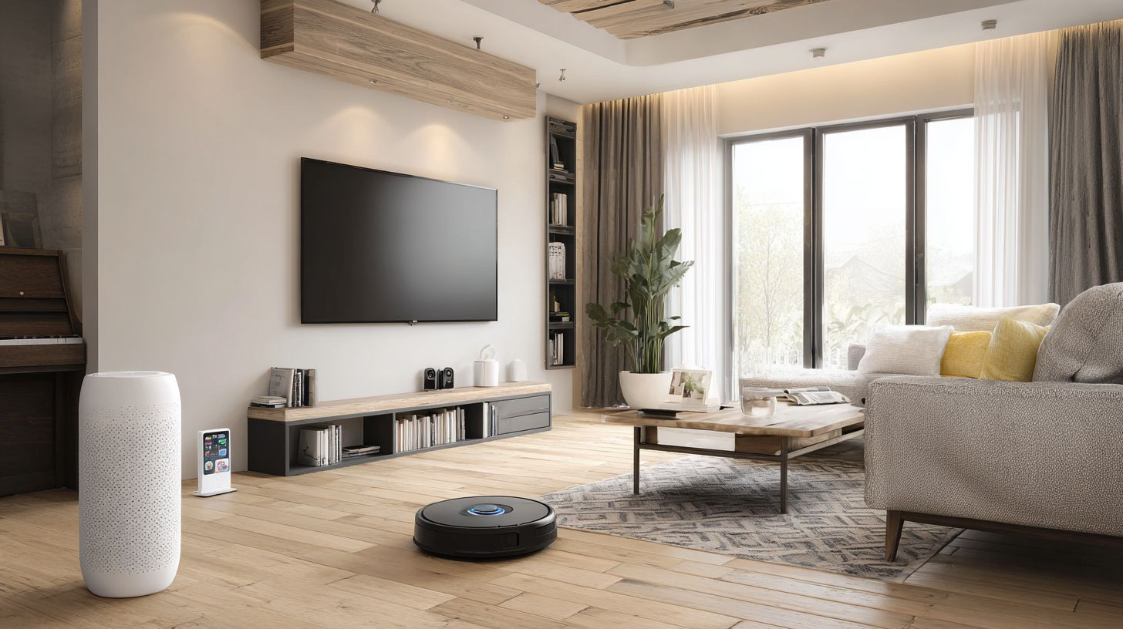
HomeKit processes 100% locally with end-to-end encryption. Your security camera data like Aqara or Nanoleaf stays on-device, dodging cloud risks. Over 40+ certified cameras work, including Eufy and Level Lock for keyless entry. iCloud keys make sharing access simple for family.
Pair Aqara Camera with Nanoleaf lights for scenes via Siri on HomePod. Thread and Bluetooth work best for motion sensors and smart thermostats. Lutron Casta dimmers add pro-level control without subscriptions. Privacy wins big for folks with video doorbells or floodlights. CNET notes its rock-solid automation once set up.
- Aqara for Zigbee sensors and hubs
- Nanoleaf for fun smart lighting
- Level Lock blends with doors seamlessly

Buying Guide and Considerations
65% of consumers prioritize privacy while avoiding subscription traps when picking smart home devices. It makes sense, right? You want gear that works without monthly fees eating into your wallet, and data staying safe on your network. Start by mapping your setup: do you lean toward Apple Home, Google Home, or Amazon Alexa? Check if devices play nice across these voice assistants to avoid headaches later.
Next, think about your daily needs. A video doorbell like Nest Doorbell shines for front-door monitoring, but pair it with motion sensors for full coverage. Budget matters too, so eye value picks under $100 that deliver on energy savings via smart plugs or bulbs. Test for Matter standard support, which cuts compatibility woes, and always enable two-factor authentication on apps.
Finally, factor in long-term costs. Devices with local processing, like Eufy Floodlight or Aqara Camera, skip cloud subs. Use VLANs to isolate IoT devices from your main network for extra security. This framework keeps your home automation smooth, saving time and money over years.

Compatibility and Ecosystem Lock-In
Matter solves 87% cross-platform issues but Thread hubs needed for full smart home harmony. Pick hubs like Aqara G4 that bridge Zigbee to Matter, letting Philips Hue lights talk to Google Home without drama. Avoid lock-in by testing devices on multiple apps first; some lighting ecosystems like Lutron Casta work everywhere via Z-Wave.
Brand | Compatible Ecosystems
Philips Hue | All (Alexa, Google, HomeKit, Matter)
Eufy | Alexa/Google only
Here's a real test: the Aqara G4 Hub connects Zigbee sensors to Matter, pulling in Level Lock and TP-Link Tapo cams effortlessly. Skip Wi-Fi-only if you have thick walls; Bluetooth or Thread holds up better. Check CNET reviews for IFTTT support too, great for custom automations like Yale lock triggering Ring Alarm.

Privacy and Security Features
Choose HomeKit/Eufy for local processing; avoid Ring's cloud-only approach to keep your footage private. Apple devices process video on-device, no uploads unless you say so, while Google Nest lets you opt-out of AI training. Amazon records interactions by default, so tweak settings early.
Platform | Privacy Approach
Apple | Local processing
Google | Opt-out AI
Amazon | Recorded (opt to delete)
Boost security with 2FA on every account and set up a VLAN for IoT devices, separating Arlo camera from your laptops. Eufy Floodlight stores 2K video locally on microSD, dodging subs. For smart speakers like Echo Studio or Nest Hub, review mic controls weekly. This setup blocks privacy concerns and keeps hackers out.

Budget vs Premium: Value Picks Under $100
TP-Link Kasa EP25 at $19 beats $99 plugs in reliability tests, handling energy savings like a champ for lamps or fans. These smart plugs track usage via app and pay for themselves fast. Premium like Ecobee thermostat costs more but saves hundreds yearly; stick under $100 for starters.
Device | Price | Key Feature
TP-Link Tapo D225 | $59 | 2K cam
GE Cync bulbs | $12 | Smart lighting
Kasa plugs | $12 | Energy monitor
ROI math: Tapo D225 cuts sub costs, recoups in 2 years vs cloud cams. GE Cync at $12 saves $50 yearly on lights, payback in 3 months. Kasa plugs at $12 track a fridge for $30 savings over 2 years. Pair with Gemini AI or Alexa Plus for schedules. Get smart thermostat features at low cost without leak detectors or air quality sensors yet.

Frequently Asked Questions

What are the best smart home devices worth buying in 2025?
The best smart home devices worth buying in 2025 include the Google Nest Hub Max for its superior smart display and AI features, Philips Hue smart bulbs for customizable lighting, and the Ecobee Smart Thermostat Premium for energy-efficient climate control. These stand out for their reliability, integration with major ecosystems like Google Home and Alexa, and innovative upgrades like Matter compatibility.

Which smart speakers are the best smart home devices to buy in 2025?
The best smart home devices to buy in 2025 are the Amazon Echo Studio for immersive audio and Dolby Atmos support, and the Apple HomePod Mini for integration with the Apple ecosystem and Siri improvements. They offer better privacy features and AI-driven personalization compared to previous models.

Are smart security cameras the best smart home devices to buy in 2025?
Yes, the Arlo Ultra 2 and Ring Spotlight Cam Pro are top smart home devices to buy in 2025. They have 4K resolution, color night vision, and AI for object detection. Their battery life and subscription-free local storage options make them ideal for home security.

What are the best smart locks to buy for a smart home in 2025?
The Yale Assure Lock 2 and August Wi-Fi Smart Lock rank as top smart home devices to buy in 2025, with keyless entry via app, voice control, and auto-unlock features using geofencing. They support Thread protocol for faster, more reliable connectivity across platforms.

Which smart vacuums are the best smart home devices to buy in 2025?
The Roborock S8 Pro Ultra and iRobot Roomba Combo j9+ rank as the best smart home devices to buy in 2025 for their self-emptying docks, mopping capabilities, and AI obstacle avoidance. These models excel in multi-floor mapping and hands-free operation via app or voice commands.

Why buy the best smart home devices for 2025 now?
Buy the best smart home devices for 2025 now to work with standards like Matter 1.2 and Thread and keep your setup ready for what comes next. You'll save on energy, get better security, and enjoy conveniences like predictive automation, with prices dropping due to market maturity.

